REDX MITAOE

TEAM: KSHATRIYA

We started our work with the REDX club, MITAOE and started with our project of ‘Crowd Management’. The tasks were distributed to different members. Mohit Kamal became the team leader. Rupesh More was given the task of coding and neural networks. Kunal Kishore took over the basic electronic building tasks. Amit Kumar took over the responsibility of regularly updating github. Jaideep Kulkarni as assigned to write the weekly reports and update the planner.

The actionable goal statements were decided.

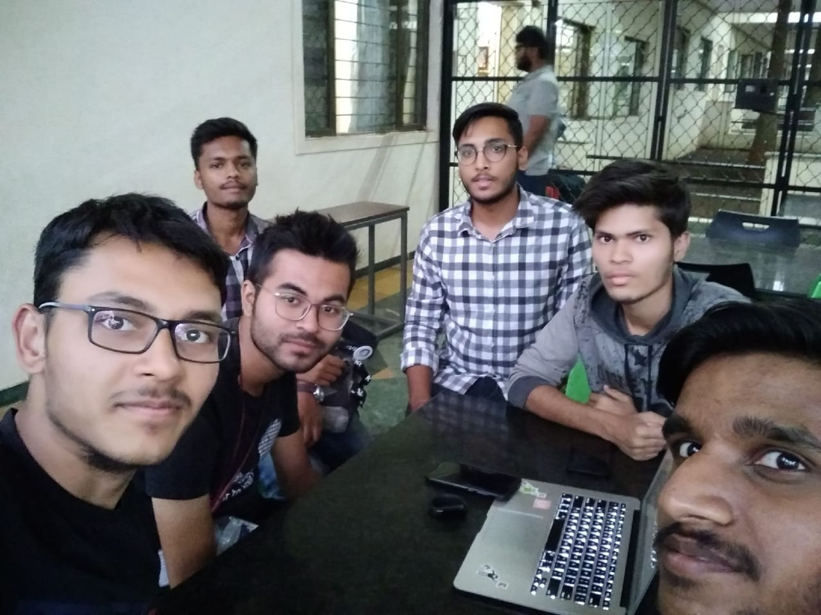
Idea 1: We decided that we would use infrared sensors to detect the thermal level in the given area and estimate the population in the area. If the heat level rises beyond a certain threshold, the module will intimate the persons in charge
Idea 2: We decided to use camera modules to count the exact number of people in the given area and also use Neural networks to predict the population inflow and outflow and hence prepare a heat map which will help analyse the time to take decisions and act.

